**Q1 : What are the various elements of the Excel interface? Describe how they're used.**

Ans : Quick Access Toolbar, Ribbon, Name Box, Formula Quick Menu, Formula Bar, Status Bar, Worksheet View Options, Zoom Slider Control, and the Zoom Percentage Indicator.

**Q2 : Write down the various applications of Excel in the industry.**

Ans :Data analyst, Data entry, Data management, Accounting, Financial analysis, Charting and graphing, Programming ,Time management, Task management etc.

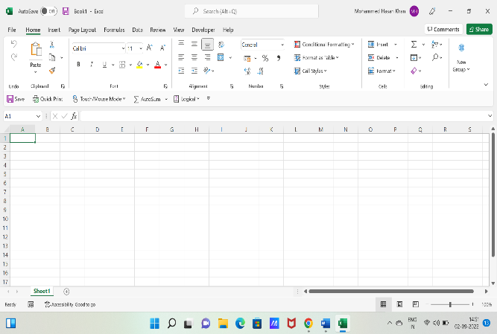**Q3 : On the ribbon, make a new tab. Add some different groups, insert commands in the groups and name them according to their commands. Copy and paste the screenshot of the steps you followed.**

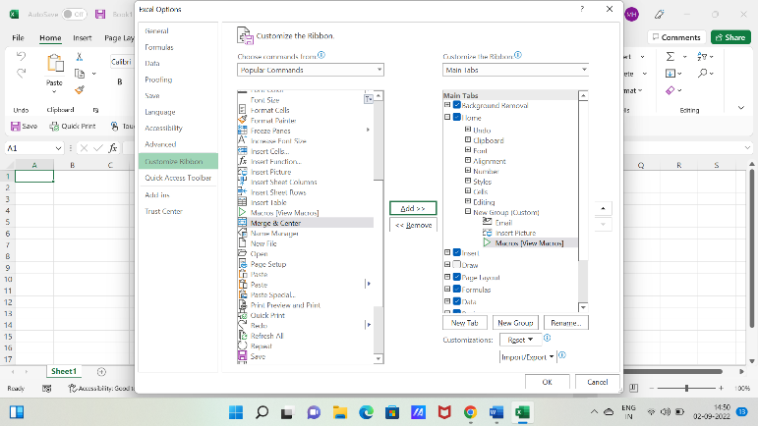

**Q4 : Make a list of different shortcut keys that are only connected to formatting with their functions.**

1. Ctrl+B: Apple bold formatting.
2. Ctrl+I: Apply italic formatting.
3. Ctrl+U: Apply underline formatting.
4. Ctrl+Shift+W: Apply underline formatting to words, but not the spaces between words.
5. Ctrl+Shift+D: Apply double underline formatting.
6. Ctrl+D: Open the Font dialog box.

**Q5 : What distinguishes Excel from other analytical tools?**

Ans : A successful Excel spreadsheet will organize raw data into a readable format that makes it easier to extract actionable insights

**Q6 : Create a table and add a custom header and footer to your table.**

Ans : On the Layout tab, under View, click Page Layout. On the Layout tab, under Page Setup, click Header & Footer. Choose from a list of standard headers or footers by going to the Header or Footer pop-up menu, and clicking the header or footer that you want.